Module Code | B9IS105
Module Name | Enterprise Information System
Date | 28-April-2020
Student number | 10387794
Student name | Srikanth Shilesh Pasam

By uploading this exam from my Moodle account I Srikanth Shilesh Pasam am confirming that this document is all my own work.
I understand that DBS will carry out checks such as text-matching (via Urkund), bench-marking and viva voce exams in order to verify the authenticity of submissions.

Please input your answers below. You may answer the questions in any order but you must ensure they are clearly labelled.

Section A

Question 1

- Discuss the relationship between information systems and business processes.

An information system is a collection of software tools used by an organization in order to streamline their functioning in an effective manner. Information systems collect, store and process data. They help manage the customers and provide business solutions. The main components of Information systems are:
- Hardware
- Software
- Databases
- Data Warehouses
- Communication

A business process is a set of procedures which define the workings of an organization. Business process help achieve the goals of an organization in a structured and organized manner. Thus business process play an integral role in defining the effectiveness of an organization.

In the current age, for any organization to be successful, they need to integrate their business processes with their information systems. Just having one of these core elements will not be sufficient. An effective and impactful organization will see the integration of their information systems with their business process thus enabling better use of data, streamlined processing methods and timely delivery of business solutions. We have multiple examples of organizations which have successfully integrated both like Amazon, ebay, etc.

- Describe, with an example, transaction processing systems (TPS) and the roles they play in a business.

Transaction processing systems are collection of information system tools which manage the collection, modification and retrieval of all transactional data. This system plays a key role in online transactions. Consider the example of airline ticketing service. While the customer is browsing through the various add-on features while booking his/her ticket, the TPS will hold the customers seat for a limited amount of time so that the same ticket will not be sold to any other customer during this time.
There are two types of transaction processing systems:
- Real time transaction processing system – This type of transaction system works near instantaneously in real time. The best example of this is the POS (Point of Sale) system where customer transactions are processed the instant they are placed thus forming the backbone for electronic purchasing facilities.
- Batch transaction processing system – This type of transaction systems process transactional data in batches. This means there is a time delay between the user request and the processing of that request. A good example for this is the check clearing system used in banks where they are processed in fixed intervals.
In the present age where the entire world is moving towards digital transactions, TPS plays an integral role in the functioning of any business. Be it the organizations internal operations or external businesses, TPS forms the key.

- Evaluate the business value of enterprise systems, using examples to justify your answer.

- Enterprise systems help manage data effectively. Every business functions on data. Enterprise systems transform this data into useful information which can help the business serve its customers effectively.
- Enterprise systems help automate customer service experience for an organization. Through the effective use of Enterprise Resource Planning, the business can automate a majority of the tasks. This automation helps in addressing customer queries quickly and easily.
- Enterprise systems help manage the scalability of a business. Scalability can benefit the business cost effectiveness along with managing the resources. Since most of the enterprise system model functions on the SaaS principle, this means scaling up when requiring additional resources during peak time and scaling down when not required will help the business function on what is exactly required.
- Enterprise system help maintain the reliability of a business. By increasing the uptime and reducing the downtime of IT availability, business can stay available for customers longer.
- Enterprise system help maintain real time data availability. Business need to always stay updated with the most recent information for it to sustain. Having real time access to the most up to date information can give the business an edge over its competitors.
- Enterprise system help optimize the supply chain management of a business. This means the business can reliably deliver its product to the customer at a lower cost.
- Enterprise systems help standardize the functioning of the business. By maintaining uniformity throughout the organization, the business can consistently perform and meet their goals.
- Enterprise systems help maintain regulatory compliance where required. Because the data is centralized and processes streamlined, the business can easily maintain any stringent regulatory compliances.

- Building new systems produces organisational change. With the aid of a diagram, identify and describe the four structural organisational changes enabled by Information Technology.

When an organization builds or implements new systems, it will cause changes across various structures within it. It can be classified into these four broad spectrums:
- Automation
- Rationalization
- Reengineering
- Paradigm Shift
Automation – This level of change enables the workforce in the organization to work effectively by reducing menial and repetitive tasks. By automating the workflow where required, the organization can focus more on increasing productivity.
Rationalization – This level involves changes in standard operating procedures. By optimizing this, the organization can build up on the efficiency of automation.
Reengineering – This level focuses on reducing the business cost.
Paradigm Shift – This level involves a complete revamp of the core principles and functioning of the entire organization.

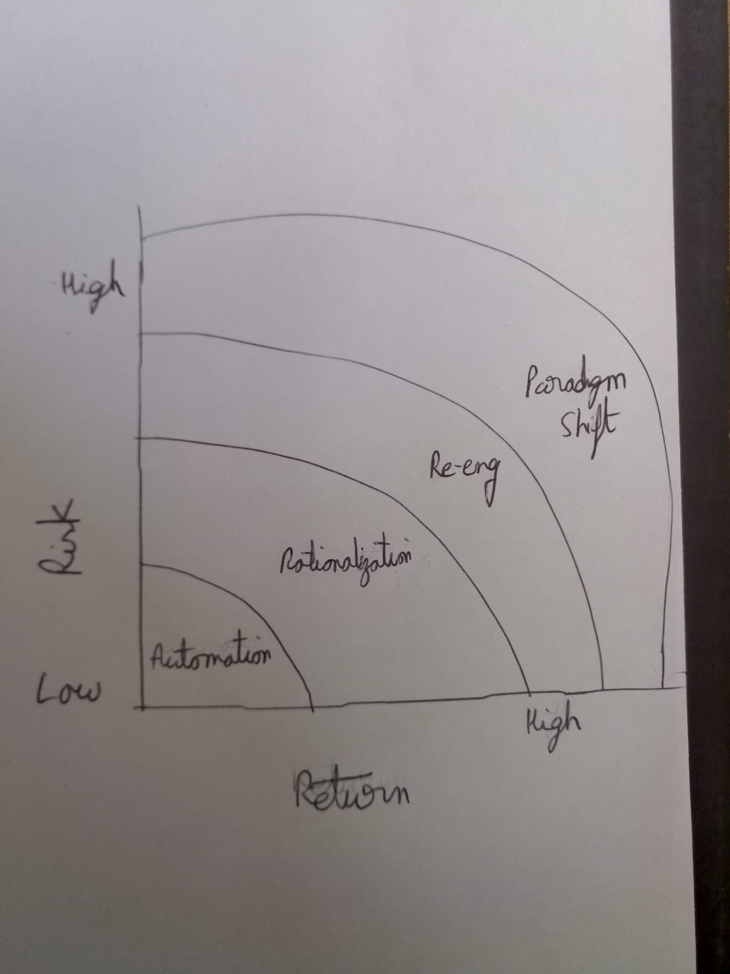

Section B

Question 2

- IaaS, PaaS, and SaaS make increasing amounts of IT maintenance someone else’s problem. Discuss, with justification, whether this can be a drawback as well as a benefit.
IaaS – Infrastructure as a Service is where the cloud provider provides the necessary hardware and networking infrastructure required by a business. It is up to the organization as to how to manage these resources, the data security features, compliance standards and updating of features. This service provides the most flexibility to the organization but it also means that it puts the most responsibility on it too.

PaaS – Platform as a Service is where the cloud provider gives the organization a platform like for example a Virtual Machine and the organization is responsible for managing this device. The cloud provider manages all the necessary hardware and networking resources. This service offers moderate flexibility and shares the responsibility between the provider and the organization.

SaaS – Software as a Service is where the cloud provider manages everything from the hardware to the software required by the organization. The organization only uses the provided service. This offers the least flexibility for the organization. The cloud provider is responsible for the most here.

The three services provided by cloud have a varied level of flexibility and responsibility shared between the provider and the organization. Considering the traditional approach as to how businesses used to function where the organization managed everything locally, cloud definitely provides a cost effective solution. Using cloud, the business can now focus more on the service it provides to its customers rather than managing the heavy grunt work of maintaining the necessary IT resources. But, this also means that business is relegating its responsibilities to an external firm. By doing this, the organization does not have full control of its sensitive data. Thus, the organization needs to balance this trade off when deciding which service best suits their business needs.
- An often-cited drawback of migration to the cloud is security and information compliance. Critically evaluate the extent to which the cloud introduces problems or highlights existing problems, and the extent to which these can be mitigated.

With the introduction of cloud platform and the various services it provides like IaaS, PaaS and SaaS a lot of business have moved to it. Cloud brings cost effective solutions to businesses where the responsibilities are shared between the organization and the cloud provider. But, this also comes with its own sets of problems for the business. Moving to cloud means moving sensitive data to a third party location managed by a third party vendor. This poses a lot of security and compliance conflicts.
Cloud providers manage their data centres in a remote location. This location at times can also be in a different country from where the business functions. This raises the issue of data integrity and compliance between the business and its customers. Certain policies which are required to be maintained by a business in their country might not be applicable where the cloud data centre is located. All these factors needs to be considered by the business before moving to the cloud. It needs to identify all such discrepancies and have policies in place to address them.
While small scale business can reap the most benefit from cloud services, large scale IT companies will need to critically evaluate if moving to cloud would provide them any benefit. Small businesses will find it difficult to manage a local server farm and networking specialists to manage them. Thus moving to cloud is the optimal solution for such organizations. But the same might not be true in case of large scale organizations which have enough resources to maintain these facilities locally. These organizations need to weigh and evaluate how much will moving to cloud be beneficial versus how much potential risk does it carry.

Question 4

Discuss the role of DevOps and cloud computing in enterprise systems.

With the advent of cloud, DevOps have become a game changer in the IT industry. Cloud has created the perfect environment for it. Instead of a project being transferred between multiple teams during the production, using cloud services all the teams can contribute to the development of the project simultaneously. This removes a lot of overhead involved between transferring files. DevOps and cloud have also reduce the time constraints involved in developing a project.
Enterprise system functions on the principle of cloud services like SaaS. By managing a single point of database, all the various teams across the organization can function effectively. This also means the projects stay updated always across the organization.

